PRIMS® U.S. Market Entry Project Plan

Prepared By:

Yash Kishor Palresha, Lila Horesh, LaDawn Spencer, Monica Ruppa, Sri Lekha Vemulakonda, Varsha Chhabria, Seyvon Kouao

Table of Contents

Project Overview 4

Objective 4

Project Scope 4

Out of Scope 4

Anticipated Timeline 6

Prototype Development 6

Clinical Studies 6

FDA Regulatory Pathway 6

Commercialization 7

Detailed Timeline 7

Assumptions 8

Budget 9

Fixed Costs 9

Variable Costs 10

Annual Fixed Costs 10

Contingency Funds 10

Quality Management 12

Resources and Project Team 13

Team Availability & Structure 13

Future Team Expansion 13

Communication 14

Communication Objectives 14

Internal Communication Practices 16

Escalation Protocol 16

Feedback Loops 16

Risk Management 17

Objectives 17

Risk Management Process 17

Mitigation Strategies 17

Risk Register 18

Stakeholders 19

Identifying Stakeholders 19

Stakeholder Management 20

Stakeholder Engagement 21

Change Management 22

Technical Integration 22

Human Factors and Stakeholder Engagement 22

Sustaining Change and Long-Term Adoption 22

Closing 23

Evaluation & Lessons Learned 23

# **Project Overview**

## Objective

* Identifying target markets within the U.S. healthcare landscape for conducting additional trials and early adoption of PRIMS
* Strategically entering the U.S. market with PRIMS technology.
* Expanding patient reach and increasing PRIMS utilization rates through partnerships and targeted initiatives.

## Project Scope

* **Development and Deployment of PRIMS:** Design, build, and implement the PRIMS platform, including hardware (medical-grade stand, CPU, cameras, monitor, UPS) and software (cloud-based application, patient dashboard, data analytics).
* **Clinical Validation:** Conduct multi-site clinical studies and trials to validate PRIMS, including data collection, academic collaborations, regulatory studies, and clinical trials in Canada, the US, and Europe.
* **Regulatory Approval:** Prepare and submit documentation for regulatory pathways (e.g., FDA De Novo submission), including pre-submission meetings, clinical data collection, and responding to regulatory feedback.
* **Training and Support:** Train healthcare professionals and provide technical support for system deployment and use in clinical settings.
* **Integration with Healthcare Providers:** Integrate PRIMS into existing clinical workflows at hospitals, clinics, and partner sites, focusing on Tier 1 hospitals and expansion to rural and underserved areas.
* **Commercialization and Expansion:** Launch PRIMS as a validated medical device in Canada, North America, Asia, and the EU, including initial market entry and global expansion.
* **Ongoing Maintenance:** Provide annual maintenance, cybersecurity, and quality management for deployed systems.

## Out of Scope

* **Direct Patient Treatment or Medication Management:** PRIMS is a monitoring and assessment tool; it does not provide direct medical treatment, prescribe medication, or adjust patient therapies
* **Home Installation and Support:** While PRIMS may have future potential for home use, this project focuses on deployment in clinical and partner healthcare settings only.
* **Integration with All EHR Systems:** The project does not guarantee integration with every electronic health record (EHR) system; only select or partner systems will be supported as per project agreements.
* **Patient Recruitment Beyond Approved Sites:** Recruitment and data collection are limited to approved clinical sites and do not include direct-to-patient or community-based recruitment outside these locations.
* **Long-term Post-Commercialization Support:** The project covers initial deployment and annual maintenance but does not include indefinite or lifetime support for all systems.
* **Research and Development of New AI Algorithms:** The project uses existing, validated AI models and does not include R&D for new machine learning algorithms during this phase.

**Anticipated Timeline**

The timeline for the PRIMS project outlines key phases, milestones, and deliverables from April 2025 to mid-2026. This plan ensures alignment with clinical validation, regulatory approvals, and commercialization goals.

Key Phases and Milestones

## Prototype Development

* + First Prototype: Developed in 2021 (now in the fifth generation)
  + Current Status: Fifth-generation prototype ready for clinical validation

## Clinical Studies

Clinical validation is divided into four streams to ensure comprehensive data collection and regulatory compliance.

|  |  |  |  |  |
| --- | --- | --- | --- | --- |
| **Stream** | **Objective** | **Start Date** | **End Date** | **Details** |
| Stream 1 | Data Collection | Ongoing | Dec 2025 | Recruitment of 100 participants in St. Johns, NL; exploring additional sites in Hamilton, ON |
| Stream 2 | Academic Studies | Feb 2025 | Dec 2025 | Collaborations with University of Cork (Ireland) and Concordia University (USA) |
| Stream 3 | Regulatory Studies | Jun 2025 | Dec 2025 | Clinical efficacy and health economics studies at University of Pennsylvania and MaineHealth/WashU |
| Stream 4 | Clinical Trials | Apr 2025 | 2027 | PRIMS used as a secondary measure in trials at Ottawa University and Haukeland University Hospital (Norway) |

## FDA Regulatory Pathway

The phased regulatory approach includes both non-device commercialization and device approval via the De Novo pathway.

|  |  |  |
| --- | --- | --- |
| **Milestone** | **Timeline** | **Details** |
| Secondary FDA Pre-Submission | Feb 2025 | Align study protocols with FDA requirements |
| Clinical Study Start | Jun 2025 | Begin data collection for De Novo submission |
| De Novo Submission | Oct 2025 | Submit clinical validation data to FDA |
| FDA Decision | Apr 2026 | Expected approval for device commercialization |
| Device Commercialization | Mid-2026 | Launch PRIMS as a validated medical device |

## Commercialization

After regulatory approval, PRIMS will be introduced into Tier 1 hospitals and other healthcare facilities globally.

|  |  |  |
| --- | --- | --- |
| **Phase** | **Timeline** | **Details** |
| Initial Market Entry | Mid-2026 | Focus on Tier 1 systems like Mayo Clinic and Kaiser Permanente |
| Expansion to Asian Markets | Late-2026 | Regulatory submissions in Japan, South Korea, and Singapore |

## Detailed Timeline

Below is a consolidated timeline for all major activities:

|  |  |  |
| --- | --- | --- |
| **Phase/Activity** | **Start Date** | **End Date** |
| Prototype Development | Completed | ~ |
| Academic Studies | Feb 2025 | Dec 2025 |
| Clinical Validation Studies | Jun 2025 | Dec 2025 |
| FDA Pre-Submission | Feb 2025 | Feb 2025 |
| FDA De Novo Submission | Oct 2025 | Oct 2025 |
| FDA Decision | Apr 2026 | Apr 2026 |
| Device Commercialization | Mid-2026 | Mid-2026 |
| Global Expansion | Late-2026 | Ongoing |

## Assumptions

All clinical studies remain on schedule without significant delays.

Regulatory approvals align with projected timelines.

Partnerships with healthcare facilities are finalized as planned.

Gantt Chart for PRIMS:

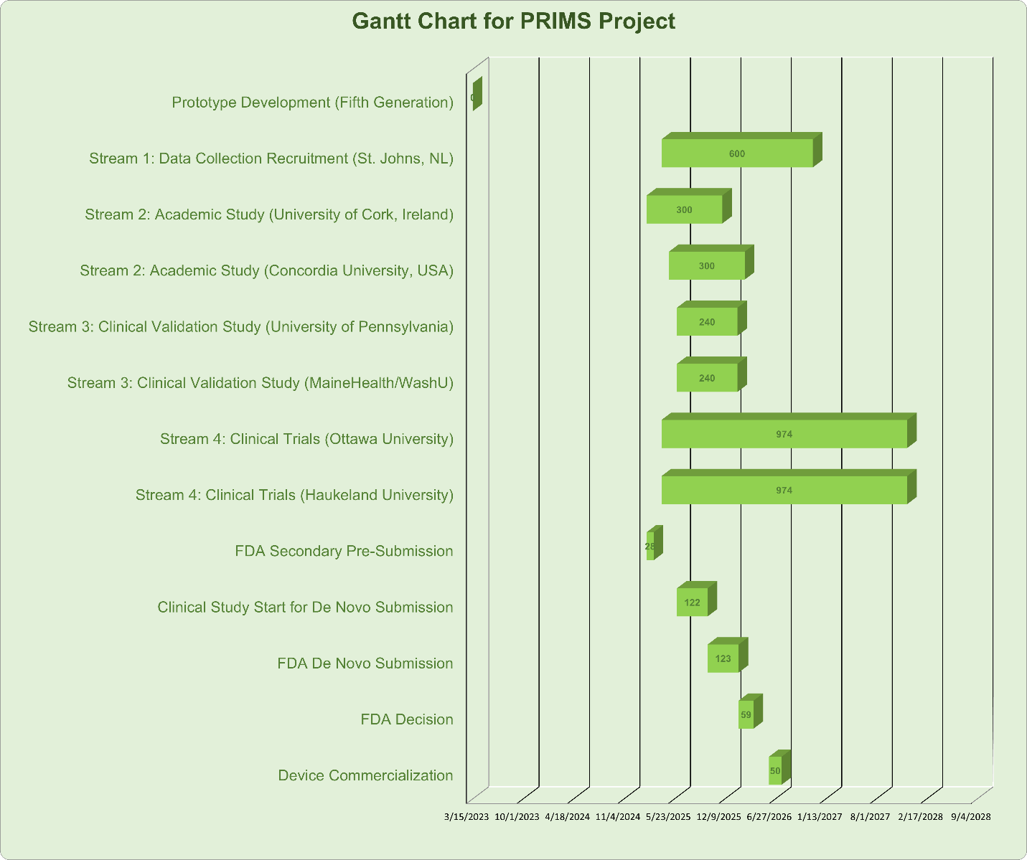

# **Budget**

The PragmaPath project is currently funded through Canadian grants, with plans to expand into markets in Canada, North America, Asia, and the EU. The budget for the PRIMS (Parkinson's Remote Interactive Management System) project is structured to ensure efficient allocation of resources across hardware, implementation, cloud services, and annual maintenance costs. This plan also includes contingency funds to address unforeseen expenses.

Cost Breakdown

## Fixed Costs

These are one-time costs incurred per system, including hardware and implementation expenses.

|  |  |  |  |
| --- | --- | --- | --- |
| **Category** | **Item** | **Cost (USD)** | **Description** |
| Hardware | Medical-Grade Stand | $4,700 | Rolling stand to house PRIMS components |
|  | CPU | $2,000 | Medical-grade IoT CPU |
|  | Audio Integration | $200 | Microphone and speaker components |
|  | Cameras | $1,000 | Orbbec cameras |
|  | Camera Upgrade (Optional) | $3,000 | Enhanced resolution imaging devices |
|  | Medical-Grade Monitor | $1,500 | 24-inch monitor meeting clinical standards |
|  | UPS Protection | $500 | Power security device |
| Cloud Services | Annual Hosting Fee | $6,000 | Cloud hosting costs per system |
| Implementation Costs | Travel (Flights) | $1,800 | Travel expenses for deployment teams |
|  | Lodging | $1,400 | Accommodation for staff during implementation |
|  | Transfers and Per Diem | $1,450 | Daily allowances and local transportation |

Subtotal Fixed Costs Per System:  
 $23,550

## Variable Costs

These costs are dependent on the scale of operations or the number of systems deployed.

|  |  |  |
| --- | --- | --- |
| **Category** | **Item** | **Cost (USD)** |
| Clinical Studies | Recruitment Incentives | Variable ($X/participant) |
| Data Collection | Staff Salaries | Variable ($X/month) |
| Marketing | Promotions/Demos | Variable ($X/system) |

## Annual Fixed Costs

These recurring costs are independent of the number of systems sold or deployed.

|  |  |  |
| --- | --- | --- |
| Category | Item | Cost (USD) |
| Cybersecurity | Annual Maintenance | $19,200 |
| Quality Management | QMS Maintenance | $27,000 |

Total Annual Fixed Costs:  
 $46,200

## Contingency Funds

To address unexpected expenses such as delays or additional requirements:

* Recommended Allocation: 10%-15% of total project cost.
* Example: For a budget of $300,000, contingency funds would range from $30,000 to $45,000.

Example Budget Calculation

If deploying 10 systems in Tier 1 hospitals over one year:

1. Fixed Costs per System:  
    $23,550 × 10 = $235,500
2. Annual Fixed Costs:  
    $46,200
3. Contingency (10%):  
    ~$28,170
4. Total Estimated Budget:  
    ~$309,870

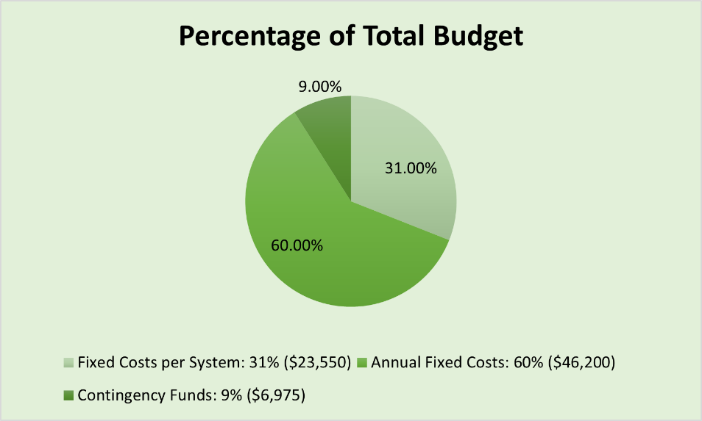

Revenue Model & ROI

Revenue Projections:

* Tier 1 Systems: $500,000 ARR/system
* Tier 2 Systems: $500,000 ARR/system
* Tier 3 Systems: $325,000 ARR/system

ROI Justification:

* Improved clinical outcomes and operational efficiency.
* Cost savings for hospitals (e.g., reducing assessment time by 20 minutes per patient).
* Market differentiation through advanced technology.

Assumptions

1. The deployment timeline aligns with regulatory approvals.
2. No significant changes to hardware or software during the project.
3. Cloud hosting fees remain constant.

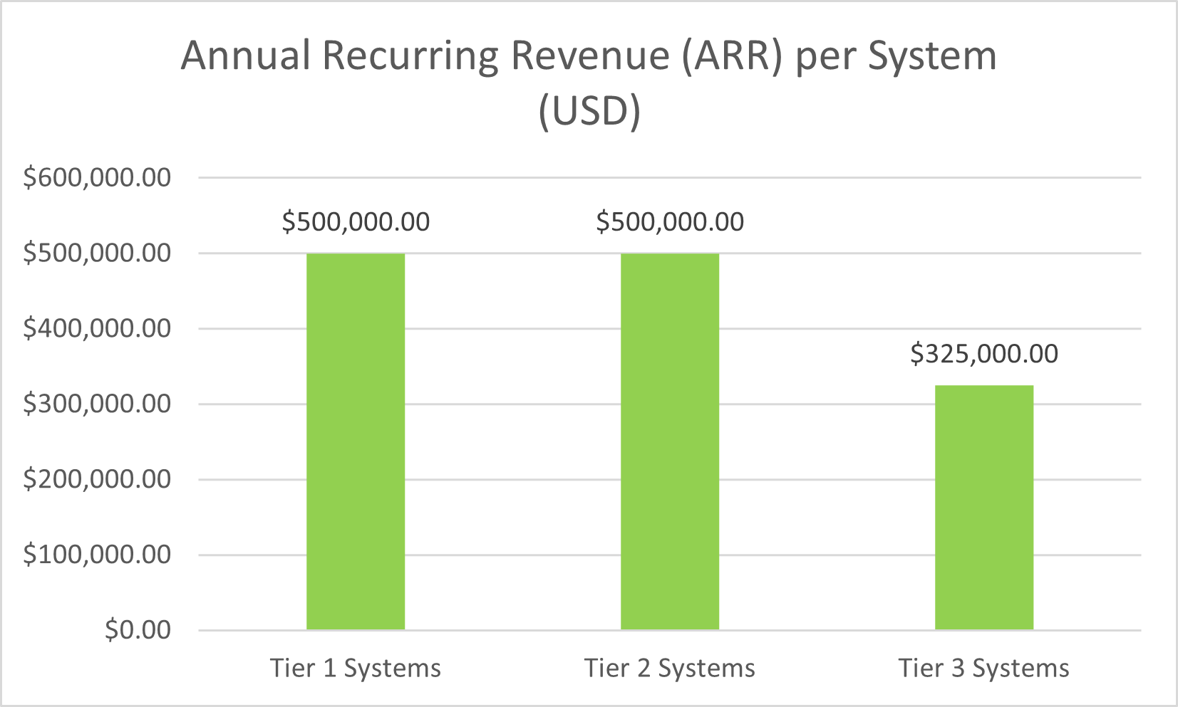

# 

# **Quality Management**

Algorithm Development and FDA Requirements

FDA Algorithm Lock Requirement: the FDA requires algorithms to be locked during the approval process. Any significant changes to the algorithm post-approval would necessitate a new submission or supplemental approval.

Current Algorithm Status: The algorithm's efficacy and robustness will be fully evaluated through the ongoing validation study.

* The final dataset from this study will allow for comprehensive analyses, including meta analyses, to refine accuracy and performance metrics.

Future Updates: While the algorithm must be locked for FDA submission, subsequent improvements or research findings could support future iterations of the device, submitted as updates or enhancements under a new regulatory pathway.

# **Resources and Project Team**

PragmaClin is a small health technology company currently composed of fewer than 20 employees.

## Team Availability & Structure

* Project Lead / Strategy Director → Oversees execution of the timeline, deliverables, and team coordination
* Clinical Validation Coordinator → Manages clinical trial sites and study timelines in Canada, the U.S., Ireland, and Asia
* Regulatory Affairs Specialist → Prepares for FDA De Novo Submission and coordinated pre submission processes
* Health Systems Analyst → Identifies U.S. market opportunities, including target hospitals and health systems for adoption
* Technical & Algorithm Development Team → Maintain the scoring algorithm and ensures compliance with regulatory standards
* UX/UI Design & Integration Lead → Focuses on clinical workflow optimization, ease of use and future self-use features
* Finance and Grant Manager → Handles funding activities from Canadian sources and supports capital raising efforts
* Marketing and Communication Advisor → Prepare educational materials, clinical site onboarding tools, and stakeholder communication

## Future Team Expansion

As the company secures additional funding, PragmaClin should plan to form a Board of Directors and recruit specialized consultants in:

* U.S. regulatory law (FDA approval)
* Health system integration
* Commercial partnerships and market launch

# **Communication**

Effective communication is vital to the successful execution of the PragmaClin (PRIMS) project, particularly as it advances through clinical validation, FDA regulatory approval, and strategic market entry in the U.S. healthcare landscape. This communication plan is designed to **communicate** key updates, **educate** internal and external stakeholders on the value and progress of PRIMS, and **gain agreement** on critical decisions throughout the project lifecycle.

By promoting alignment within the project team and maintaining a consistent flow of accurate information, the plan enhances transparency, minimizes risk, and supports operational efficiency. Clearly defined communication channels, roles, and feedback mechanisms further strengthen collaboration and stakeholder engagement, ensuring that all project participants remain informed, involved, and aligned at every stage.

## Communication Objectives

* Deliver timely updates to maintain alignment across teams and decision-makers.
* Ensure transparency around regulatory, financial, and clinical progress to support informed decision-making.
* Facilitate collaboration between cross-functional groups (regulatory, technical, research).
* Lay the foundation for future external stakeholder engagement (e.g., payers, board members).

**Communication Matrix**

|  |  |  |  |  |  |
| --- | --- | --- | --- | --- | --- |
| **Stakeholder (Who)** | **Strategy** | **Purpose**  **(What)** | **Tool**  **(How)** | **Frequency**  **(when)** | **Responsible Role** |
| Hope Cahill (Sponsor) | Manage Closely | Ensure project alignment  Review risks and resource needs | -Executive summaries, 1:1 update  -Email briefings for urgent updates | Bi-weekly  Immediate escalation of critical issues | Project Manager |
| Bronwyn Bridges (CEO) | Manage Closely | Communicate ROI, milestones, and long-term impact | -Milestone reports  -Briefings via email/presentation | Monthly or at key milestones | Project Manager |
| Thomas Arena (Advisor) | Keep Informed | |  | | --- | | Provide regulatory updates  Compliance checkpoints | |  | | Email, Shared document | Bi-weekly | Regulatory Lead |
| Project Team | Manage Closely | Share tasks, progress updates, raise blockers  Feedback loops | - Team collaboration chat (Slack)  - Team meeting (in-depth)  -Shared docs | Ongoing chat as needed  Weekly meetings | Project Manager |
| Regulatory Bodies (FDA) | Keep Satisfied | Submit documentation, respond to feedback | -Document submission and Formal reports  -Email for Q&A and clarifications | As per submission milestones  Monthly status emails (during review) | Regulatory Lead |
| Health Systems & Clinics | Keep Informed | Pilot plans, implementation details, training needs | Outreach emails, deployment guides | Monthly | Project Manager |
| Patients (End Users) | Keep Informed & Educate | Raise awareness, explain benefits, build trust in PRIMS, gather feedback | Surveys Multilingual flyers, Interviews | Bi-weekly during active pilot sites | Project Team |
| Insurance Companies | Keep Satisfied | Demonstrate clinical value and economic impact of PRIMS,  Support affordable payment models | Executive summaries, presentation decks | As needed | Project Manager |

## Internal Communication Practices

The PRIMS team leverages Slack as the primary platform for real-time communication and collaboration. Based on input from PragmaClin, the following practices have been adopted to maintain operational efficiency:

* A dedicated Slack channel facilitates day-to-day coordination and quick exchanges
* Weekly status updates are posted in Slack, covering:
  + Key accomplishments
  + Upcoming milestones
  + Challenges and opportunities
* Team members can tag senior contacts for immediate attention or escalation
* Slack calls are arranged ad hoc for deeper alignment or clarification when necessary

## Escalation Protocol

To ensure timely resolution of project roadblocks, an escalation process is in place. If any critical blockers arise during project execution, team members are encouraged to escalate issues promptly through the following steps:

* **Primary Escalation:** Tag **Thomas Arena (Advisor)** directly in the Slack channel for immediate visibility and guidance.
* **Backup Contacts:** If Thomas is unavailable, communication should be directed to Hope Cahill (Sponsor).
* **Urgent Issues:** For time-sensitive challenges requiring discussion, the team may request a Slack call to collaboratively address the issue.

## Feedback Loops

* Stakeholder and team feedback is encouraged via Slack polls, informal check-ins and shared documents.
* Feedback loops are integrated into reporting cycles to drive improvements and inclusive decision-making.
* NDAs will be signed by all team members to ensure confidentiality.

# **Risk Management**

This plan outlines a proactive approach to identifying, assessing, mitigating, and monitoring key risks associated with PragmaClin’s project execution, particularly in clinical validation, FDA approval, and market strategy.

## Objectives

* **Early Identification** of risks impacting timelines, regulatory approvals, and revenue.
* **Assessment & Prioritization** by classifying risks as High, Medium, or Low based on likelihood and impact.
* **Mitigation Strategies** to reduce risk probability and impact.
* **Ongoing Monitoring** through regular reviews and updates.

## Risk Management Process

* **Risk Identification:** Key risks include delays in FDA approval, validation testing, provider adoption, marketing execution, revenue generation, and unvalidated FDA outcomes.
* **Assessment & Classification:** Risks are rated by likelihood and impact.

## Mitigation Strategies

1. Engage FDA and testing partners early.
2. Allocate contingency resources.
3. Implement provider education and pilot programs.
4. Conduct continuous market research and quality assurance.

Monitoring & Reporting

1. Maintain a dynamic risk register.
2. Use Key Risk Indicators (KRIs).
3. Schedule periodic risk review meetings.
4. Activate contingency plans as needed.

## Risk Register

The following table summarizes the key risks, their preliminary classification, and proposed mitigation strategies:

|  |  |  |  |  |
| --- | --- | --- | --- | --- |
| **Risk** | **Likelihood** | **Impact** | **Level** | **Key Mitigation** |
| FDA Approval Delay | High | High | High | Early FDA engagement, expert consultants |
| Validation Testing Delays | Medium | High | High | Robust protocols, schedule buffers |
| Provider Acceptance | Medium | Medium | Medium | Education, pilots, real-world evidence |
| Marketing Challenges | Medium | Medium | Medium | Market research, tailored campaigns |
| Revenue Challenges | Medium | High | High | Refined models, alternative streams |
| Unvalidated FDA Approval | Low | High | Medium-High | Plan for additional studies, explore alternative paths |

Note: The likelihood and impact ratings are preliminary assessments and should be reviewed as additional project data becomes available.

# **Stakeholders**

## Identifying Stakeholders

There are many ways to identify the key stakeholders that may be involved in the project and prioritize them depending on a set of criteria. The stakeholder identification matrix given below gives a picture of different stakeholders and their importance to the project, 3 is the highest priority value and 1 being the lowest priority value a stakeholder can get.

STAKEHOLDER IDENTIFICATION AND PRIORITIZATION MATRIX

|  |  |  |  |  |  |  |  |  |
| --- | --- | --- | --- | --- | --- | --- | --- | --- |
|  | **Stakeholders** | | | | | | | |
| **Values important to the stakeholders** | **Hope Cahill (Sponsor)** | **Bronwyn Bridges (CEO)** | **Thomas Arena (advisor)** | **Project Manager & Team** | **Regulatory Bodies** | **Target Health Systems & Clinics** | **Patients** | **Insurance Companies (payers)** |
| Power | 3 | 3 | 3 | 2 | 3 | 1 | 1 | 1 |
| Interest | 3 | 2 | 3 | 2 | 1 | 2 | 3 | 1 |
| Influence | 3 | 1 | 3 | 3 | 3 | 1 | 1 | 2 |
| Impact | 3 | 1 | 1 | 1 | 1 | 3 | 3 | 1 |
| Urgency | 2 | 1 | 3 | 3 | 1 | 1 | 1 | 1 |
| Legitimacy | 1 | 3 | 2 | 3 | 3 | 2 | 2 | 2 |
| Total | 15 | 11 | 15 | 14 | 12 | 10 | 10 | 8 |
| Priority | Key | Secondary | Key | Key | Key | Secondary | Secondary | Other |

STAKEHOLDER REGISTER

|  |  |  |  |  |
| --- | --- | --- | --- | --- |
| **Stakeholder** | **Role** | **Interest in Project** | **Priority** | **Engagement Strategy** |
| Hope Cahill (Sponsor) | Project sponsor provides strategic oversight. | Successful implementation of market strategy and early adoption of PRIMS. | Key | Actively involved in key decisions and updates. One-on-one briefings as needed. |
| Bronwyn Bridges (CEO) | Visionary ensures alignment with company goals. | PRIMS to be adopted in the U.S. for broader impact. | Secondary | Provide high-level reports and align strategy with company goals. Invite to major milestone reviews. |
| Thomas Arena | Stakeholder (advisor). | Supports compliance and strategic alignment. | Key | Keep informed on regulatory research and market readiness progress. |
| Project Team | Executing research, planning, and documentation | Academic success, project outcomes, and learning experience | Key | Collaborative tools (e.g., shared docs, dashboards), weekly syncs. |
| Regulatory Bodies | Evaluate and approve PRIMS technology. | Compliance, safety, data integrity, and patient rights. | Key | Complying with HIPAA guidelines, transparent communication, and continuous feedback integration. |
| Target Health Systems & Clinics | Potential early adopters. | Better care delivery tools for Parkinson’s; interested in data security. | Secondary | Outreach strategy based on ICP findings; include them in the pilot planning phase. |
| Patients | End users. | Improved access to Parkinson’s treatment. | Secondary | Address via ICP, include feedback in future implementation stage. |
| Insurance Companies | Payers. | Provide coverage for patients. | Other | Formulating payment plans that are affordable for patients as well as profitable to the insurance companies. |

## Stakeholder Management

To effectively manage stakeholders and understand their needs, it is crucial to continuously monitor Relationships, Communications, and Lessons Learned throughout the project.

* Understand stakeholder assumptions.
* Clarify stakeholder assumptions.
* Achieve according to stakeholder assumptions.
* Reconfirm stakeholder expectations.
* Adjust strategies as needed.

## 

## Stakeholder Engagement

A primary tool used in this plan is the stakeholder engagement assessment matrix.

|  |  |  |  |  |
| --- | --- | --- | --- | --- |
| **Stakeholder** | **Current Position** | **Target Position** | **Barriers to Change** | **Strategy** |
| Hope Cahill (Sponsor) | Leading | Leading | Competing day-to-day priorities. | Maintain engagement with regular strategic updates and demonstrate momentum. |
| Bronwyn Bridges (CEO) | Supportive | leading | Competing priorities, unclear ROI. | Highlight strategic alignment, provide ROI models, and ensure regular executive briefings. |
| Thomas Arena | Supportive | Leading | Limited power. | Keep him informed with clear task roles and updates; involve in decision checkpoints. |
| Project Team | Leading | leading | Scope creep, resource limitations, stakeholder alignment challenges. | Foster agile practices, celebrate small wins, and ensure ongoing support from leadership. |
| Regulatory Bodies | Resistant | Supportive | Concerns about HIPAA compliance, data security, and patient safety. | Engage early, emphasize compliance-by-design, and offer pilots or sandbox participation. |
| Target Health Systems & Clinics | Neutral | Supportive | Workflow disruption, implementation cost, staff training. | Offer training, implementation support, and co-developed ROI/value frameworks. |
| Patients | Unaware | Neutral | Lack of awareness, data privacy concerns, and uncertainty about affordability and insurance coverage. | Launch patient education campaigns, assure transparency, offer multilingual/accessible interfaces. |
| Insurance Companies | Unaware | Supportive | Comparatively lower profit margins | Share real-world outcome data, partner on value-based care pilots, and emphasize preventive care benefits. |

# **Change Management**

Successful implementation of PRIMS requires a structured change management strategy that addresses both the technical integration of the system and the human factors influencing adoption. This strategy ensures that stakeholders (clinicians, healthcare administrators, IT personnel, patients advocacy, etc.) are actively engaged throughout the transition process.

## Technical Integration

To seamlessly integrate PRIMS into healthcare settings, the implementation will follow a phased rollout approach, prioritizing Tier 1 institutions such as large integrated delivery networks and specialty neurology clinics that are well-equipped for adopting advanced diagnostic tools. Tier 2 and Tier 3 facilities (rehabilitation centers and elderly care facilities) will follow deployment models with tailored training and support for adoption.

The WBS will be developed to incorporate regulatory approvals, pilot testing, and technical support. To minimize workflow disruptions, PRIMS will be embedded into existing clinical processes. Throughout implementation, audits will be conducted to monitor performance and user adoption, ensuring that any technical challenges are promptly addressed. A post-implementation support framework will be developed to provide any new system updates, help desk services, and training modules to maintain operational efficiency.

## Human Factors and Stakeholder Engagement

Effective change management also requires engaging the human side of adoption, particularly among clinicians, therapists, and healthcare administrators who will interact with PRIMS daily. A stakeholder engagement plan will be implemented to communicate the value proposition of PRIMS (ability to enhance diagnostic accuracy, reduce assessment subjectivity, and improve patient outcomes). PRIMS will be reinforced as a supportive tool rather than a replacement to build trust with providers.

Programs like hands-on workshops and virtual training sessions will be offered. Clinicians will also be offered professional development incentives, such as continuing education credits, to encourage participation.  ­Resistance to change is anticipated, particularly from clinicians who may be wary of AI-driven assessments or concerned about disruptions to their workflow. Structured feedback sessions will be conducted to mitigate these concerns and allow stakeholders to voice problems or suggestions for the system.

## Sustaining Change and Long-Term Adoption

Post-implementation surveys and data-driven assessments will be used to measure user satisfaction and identify areas for improvement.  Use of both old and new assessment methods will be maintained, if necessary, until PRIMS is fully integrated into workflows.

# **Closing**

Project closure will be determined once all key deliverables outlined in the project scope and WBS have been completed, verified, and accepted by relevant stakeholders. This includes full deployment of PRIMS across the designated Tier 1, 2, and 3 institutions, completion of all training and support materials, and documentation of regulatory approvals and compliance.

## Evaluation & Lessons Learned

A formal project review will be conducted following closing.

Key challenges will be documented to inform future projects with similar components. Stakeholder feedback will be gathered through post-implementation audits and surveys, analyzed as part of lessons learned to improve future planning and risk mitigation. All findings will be compiled in final project documentation.